VISITOR / EMPLOYEE SIGN-IN SHEET 2.0
Branch: | Month: 2021
This information will not be shared, sold, or distributed in any way by ABL Employment, except in the event that Public Health authorities require it for contact tracing due to possible COVID-19 exposure.

BY SIGNING IN, YOU CONFIRM THAT YOU DO NOT HAVE ANY OF THE FOLLOWING NEW OR WORSENING SYMPTOMS OR SIGNS. SYMPTOMS SHOULD NOT BE CHRONIC OR RELATED TO OTHER KNOWN CAUSES OR CONDITIONS: [descriptions page 2]
not related to getting a COVID-19 vaccine in the last 48 hours

♦Fever or chills ♦ Difficulty breathing or shortness of breath ♦ Cough ♦ Sore throat, trouble swallowing ♦ Runny nose/stuffy nose or nasal congestion ♦ Decrease or loss of smell or taste ♦ Nausea, vomiting, diarrhea, abdominal pain ♦Unusual headache ♦ Not feeling well, extreme tiredness, sore muscles ♦ Pink eye
♦ You have travelled outside of Canada in the last 14 days
♦ You have been in close contact with a confirmed or probable case of COVID-19
♦ A doctor, health care provider, or public health told you that you should currently be isolating
♦You received COVID Alert exposure notification on your cell & have not yet received results
IF you answer YES to any of the above, DO NOT ENTER and go home to self-isolate immediately
and contact your healthcare provider or Telehealth Ontario (1 866-797-0000)

Date | Name | Phone

DESCRIPTIONS OF COVID SIGNS AND SYMPTOMS –
VISITOR SIGN-IN SHEET 2.0 [pg. 2]
Fever and/or chills  Temperature of 37.8 degrees Celsius/100 degrees Fahrenheit or higher | 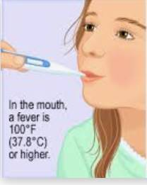
Cough or barking cough (croup)  Continuous, more than usual, making a whistling noise when breathing, not related to other known causes or conditions (for example, asthma, post-infectious reactive airways, COPD) | 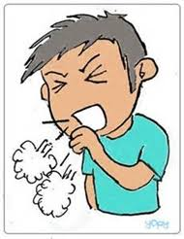
Shortness of breath  Out of breath, unable to breathe deeply, not related to other known causes or conditions (for example, asthma) | 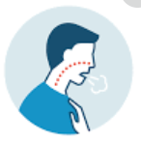
Decrease or loss of smell or taste  Not related to other known causes or conditions (for example, allergies, neurological disorders) | 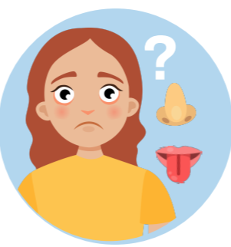
Sore throat
Not related to other known causes or conditions (for example, seasonal allergies, acid reflux)
Difficulty swallowing
Painful swallowing, not related to other known causes or conditions
Pink eye  Conjunctivitis, not related to other known causes or conditions (for example, reoccurring styes) | 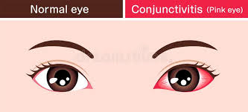
Runny or stuffy/congested nose
Not related to other known causes or conditions (for example, seasonal allergies, being outside in cold weather)
Headache that’s unusual or long lasting not related to getting a COVID-19 vaccine in the last 48 hours
Not related to other known causes or conditions (for example, tension-type headaches, chronic migraines)
Digestive issues like nausea/vomiting, diarrhea, stomach pain  Not related to other known causes or conditions (for example,  irritable bowel syndrome, menstrual cramps) | 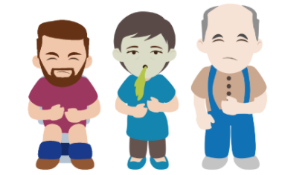
Muscle aches that are unusual or long lasting not related to getting a COVID-19 vaccine in the last 48 hours
Not related to other known causes or conditions (for example, a sudden injury, fibromyalgia)
Extreme tiredness that is unusual not related to getting a COVID-19 vaccine in the last 48 hours: Fatigue, lack of energy, not related to other known causes or conditions (for example, depression, insomnia, thyroid dysfunction)

