PERSONAL PROTECTIVE EQUIPMENT NEEDS ASSESSMENT
Use this checklist as a guide to track PPEs, training and compliance to keep your workers safe from worksite COVID-19 hazards
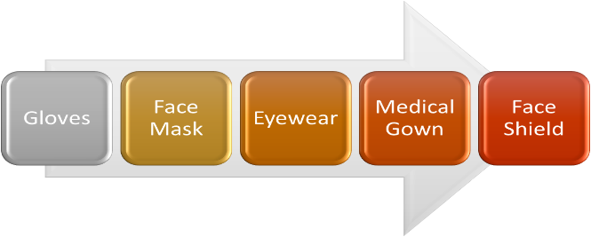
 | YES | NO | DATE COMPLETED | COMMENTS
Has a hazard assessment to identify and control physical and health hazards been completed? If not, perform a hazard assessment. | ☐ | ☐
Have engineering and/or administrative controls been applied prior to the use of PPE? If not, apply them first if applicable and appropriate.  - Physical barrier (e.g. plexiglass) between workers and visitors  - Maintain physical distance of at least 2m  - Staggering schedules to prevent overlap and minimize crowding  - Arrange working areas to create at least 2m spacing  - Remove excess items  - Disinfect all areas workers/visitors came into contact with | ☐  ☐  ☐  ☐  ☐  ☐  ☐ | ☐  ☐  ☐  ☐  ☐  ☐  ☐
Has appropriate PPE that matches the hazard been identified and provided to employees for use?  - Mask  - Face shield/Eye protection  - Isolation gown  - Gloves  - Hand hygiene | ☐  ☐  ☐  ☐  ☐  ☐ | ☐  ☐  ☐  ☐  ☐  ☐
Has the effectiveness of the PPE program been reviewed, updated and evaluated periodically? | ☐ | ☐
Have employees been trained on the use and care of the PPE? | ☐ | ☐
Have employees been trained on the limitations of the PPE? | ☐ | ☐
Is the PPE training documented and kept on file? | ☐ | ☐
Are supervisors enforcing the use of required PPE? | ☐ | ☐
Is PPE inspected regularly and properly maintained? | ☐ | ☐
Is worn and damaged PPE removed from service & replaced? | ☐ | ☐
When the following type of PPE is necessary, is the employer providing and paying for the PPE? | ☐ | ☐
If the employee provides his/her own PPE, is it adequate to protect the worker from hazards in the workplace? | ☐ | ☐

If “NO” is the response to any of the above questions, further review and actions may be required to ensure are the workers using appropriate PPE as applicable (i.e. safety glasses, goggles, face shields, masks, etc)

